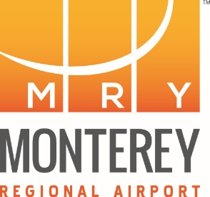

PUBLIC NOTICE
Notice of Cancellation of Regular Board Meeting

The Regularly Scheduled Meeting of
Wednesday, December 21, 2022 at 9:00 AM
Scheduled to be held at the
Monterey Regional Airport Board Room
2nd Floor of the Airport Terminal Building
200 Fred Kane Drive
Monterey, CA 93940

HAS BEEN CANCELLED

This meeting has been rescheduled to
Wednesday, December 14, 2022 at 9:00 AM
Scheduled to be held at the
Monterey Regional Airport Board Room
2nd Floor of the Airport Terminal Building
200 Fred Kane Drive
Monterey, CA 93940

For additional information, please call the
Monterey Regional Airport at (831) 648-7000.

